AI Assisted Anesthesia Machine

ABSTRACT
The Personalized Anesthesia Management project focuses on predicting postoperative complications in patients undergoing surgery, utilizing machine learning algorithms such as Support Vector Machine (SVM), Random Forest, and XGBoost. The dataset provides detailed information about patients, including demographic data, surgery type, anesthesia used, surgical duration, and postoperative conditions. The primary goal of the project is to develop a predictive model that can assess the likelihood of complications, such as nausea, mild bleeding, respiratory distress, or delayed recovery, based on preoperative and intraoperative factors. The outcome of the surgery is classified into two categories: 0 (no complications) and 1 (complications present). This model aims to assist healthcare providers in managing patient anesthesia more effectively by identifying high-risk patients and optimizing perioperative care, thus improving surgical outcomes and enhancing patient safety. The system is implemented with a frontend in HTML, CSS, and JavaScript, and the backend is powered by Python, ensuring a user-friendly interface and robust prediction capabilities.

Keywords: Anesthesia management, postoperative complications, machine learning, SVM, Random Forest, XGBoost, personalized care, surgery prediction, patient safety.

INTRODUCTION

Motivation
Anesthesia management plays a critical role in the success of surgeries and in minimizing postoperative complications. Personalized anesthesia care, tailored to the individual needs of each patient, can significantly improve recovery outcomes and reduce the risks of complications. Despite advancements in anesthesia practices, postoperative complications such as nausea, bleeding, and delayed recovery continue to be major concerns. By leveraging machine learning techniques, it is possible to predict complications before they occur, providing healthcare providers with insights to make better decisions and optimize patient care. The motivation behind this project is to create a predictive model that can assist in early identification of high-risk patients, thus improving the quality of anesthesia management and enhancing patient safety during and after surgery.

Problem Statement

Despite significant improvements in surgical and anesthesia techniques, postoperative complications remain a prevalent issue, affecting patient recovery and hospital resources. The lack of personalized approaches in predicting postoperative complications leads to inefficient management of patients. There is a need for a system that can predict potential complications based on preoperative and intraoperative factors, allowing for better anesthesia management and early intervention. This project seeks to address this gap by developing a machine learning-based system that predicts postoperative complications using patient-specific data, enhancing personalized care and improving surgical outcomes.

Objective of the project

The primary objective of this project is to develop a machine learning-based system that predicts postoperative complications based on patient data. The specific objectives are:

- To analyze and preprocess the dataset, including cleaning the data and handling missing values.

- To implement machine learning models such as SVM, Random Forest, and XGBoost to predict complications after surgery.

- To evaluate the performance of these models using metrics such as accuracy, precision, recall, and F1-score.

- To create a user-friendly web application with a frontend in HTML, CSS, and JavaScript for inputting patient data and displaying prediction results.

- To provide healthcare providers with a tool that can predict and prevent potential postoperative complications, ultimately improving patient care and safety.

Scope of the project
The scope of this project is to develop a predictive model that classifies the outcome of surgeries into two categories: no complications (0) and complications present (1). The project focuses on analyzing a dataset containing various features such as patient demographics, surgery type, anesthesia type, surgical duration, and postoperative notes. The project will utilize machine learning algorithms, including SVM, Random Forest, and XGBoost, to predict postoperative complications. The system will be deployed with a user-friendly frontend built with HTML, CSS, and JavaScript, while the backend will be powered by Python for model training and predictions. The project is limited to predicting complications based on the provided dataset and does not address other areas of anesthesia management such as anesthesia dosing or real-time monitoring during surgery.

SYSTEM ANALYSIS

Existing System
In traditional anesthesia management systems, decisions regarding patient anesthesia care are largely based on historical data, physician experience, and general guidelines. The prediction of postoperative complications is typically done manually, relying on patient monitoring during surgery and post-surgery observations. While some hospitals use basic decision support systems to manage and predict complications, these systems mainly focus on general patient information and lack personalized predictive capabilities.
Disadvantages of Existing System:
- Limited Predictive Power: Existing systems do not effectively predict complications based on individual patient data, leading to reactive rather than proactive care.
- Manual Intervention: The lack of automated prediction models means decisions are often based on the experience and judgment of medical professionals, which can be prone to human error.
- Generalized Approach: Traditional systems use a "one-size-fits-all" approach, ignoring individual patient differences and specific risks that could lead to complications.
- Delayed Response: Since complications are often identified postoperatively, there may be delays in addressing issues, which could have been managed more efficiently if predicted in advance.
- Inefficiency: The traditional system requires significant manual input from doctors, nurses, and anesthetists, leading to a waste of resources and time.
Proposed System:
The proposed system aims to leverage machine learning algorithms—Support Vector Machine (SVM), XGBoost, and Random Forest—to predict postoperative complications by analyzing patient data such as age, gender, surgery type, anesthesia type, surgery duration, and postoperative notes. By integrating predictive modeling, the system will provide real-time insights that help healthcare providers make informed decisions and anticipate complications before they occur.
The proposed system incorporates advanced machine learning models, such as SVM, XGBoost, and Random Forest, to create a predictive model for postoperative complications. These models will analyze patient data preoperatively, during surgery, and postoperatively to predict the likelihood of complications occurring. The system will enable healthcare professionals to identify high-risk patients early and personalize anesthesia management to improve patient outcomes.
Advantages:
- Personalized Predictions: The system uses individual patient data to make predictions, allowing for more tailored anesthesia management, improving patient care.
- Proactive Care: By predicting complications in advance, healthcare providers can take preventive measures before the issues arise, leading to quicker interventions and better recovery outcomes.
- Enhanced Accuracy: Machine learning algorithms like SVM, Random Forest, and XGBoost can analyze large and complex datasets, identifying patterns that may not be apparent to human doctors. This leads to more accurate predictions.
- Efficiency: The system reduces manual efforts and automates the process of complication prediction, allowing healthcare providers to focus more on patient care than on administrative tasks.
- Scalability: Machine learning models can be retrained with new data over time, making the system scalable and adaptable to changing medical practices and patient profiles.
- Real-Time Decision Support: The predictive nature of the system provides real-time feedback, enabling healthcare providers to make decisions based on up-to-date information, improving the overall quality of care.
- Data-Driven Decisions: The system takes into account a wide range of factors, allowing for data-driven decision-making rather than relying solely on physician experience.

Project flow
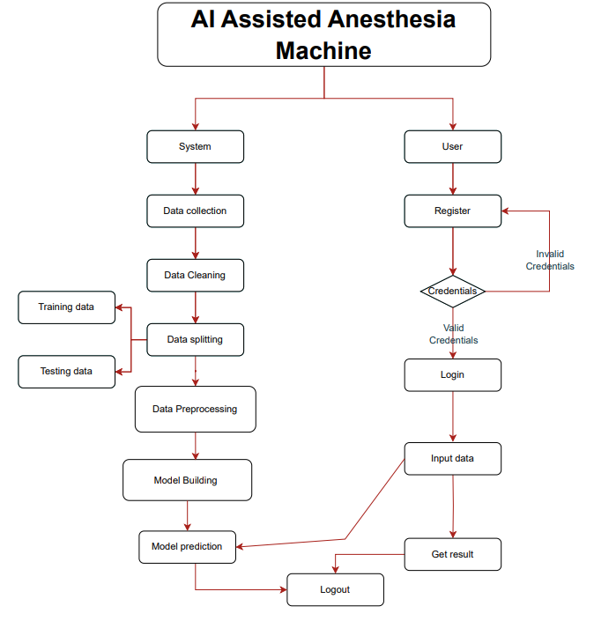

Architecture Diagram

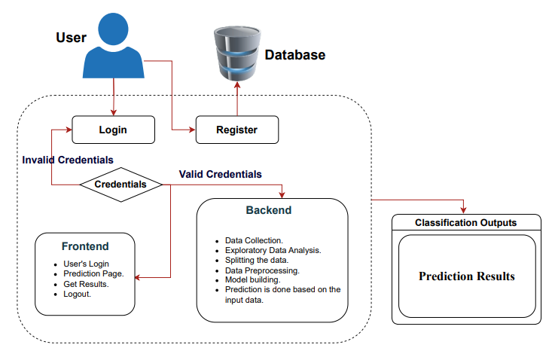

Top of Form
Bottom of Form

Hardware Requirements

- Processor - I3/Intel Processor
- Hard Disk - 160GB
- Key Board - Standard Windows Keyboard
- Mouse - Two or Three Button Mouse
- Monitor - SVGA
- RAM - 8GB

Software Requirements

- Operating System : Windows 7/8/10
- Server side Script : HTML, CSS, Bootstrap & JS
- Programming Language : Python
- Libraries : Flask, Pandas, MySQL. Connector, Scikit-learn
- IDE/Workbench : VS Code
- Technology : Python 3.8+
- Server Deployment : Xampp Server

MODULES

6.1 USER
Login Page
Allow users to login the application and navigate through register option.
Registration Page
Allows new users to create an account by entering essential details and securing their credentials.
Home Page
Serves as the main dashboard for users, offering access to features like the performance Page, Prediction Page, About Page, and Logout.
About Page
Contains a brief overview and detailed information about the project.
Performance Page
Displays performance metrics of the predictive models, including accuracy and algorithm name.
Prediction Page
Provides accurate predictions based on the input features given by the user.
Logout Page
Allows users to securely exit their accounts and terminate active sessions and land in the login page for further login.

6.2 SYSTEM

1.1 Data Collection:
The data collection phase involves gathering a diverse dataset of historical vegetable prices along with key features like season, month, temperature, crop condition, and disaster history. Data is sourced from agricultural databases and local markets to ensure broad coverage. Each entry is labeled with a price per kilogram, allowing the model to learn the relationship between these factors and price changes. The dataset is then split into training and testing sets, typically 80% for training and 20% for testing, to build and evaluate the model effectively.

1.2 Data preprocessing:
It prepares the raw data by cleaning, transforming, and structuring it for model training. This includes handling missing values by filling or removing them, scaling numerical features for consistency, and encoding categorical variables like crop conditions. Outliers are managed to avoid skewing results, ensuring the dataset is clean and reliable for accurate model performance. This process provides a solid foundation for training the predictive model.

1.3 Model Training: Training the models with random forest, xgboost.
1.4 Evolution Metrics: Evaluation metrics quantify how well a model performs on a given task, helping determine its accuracy, precision, recall, and other performance aspects. Metrics allow for direct comparisons between different models or configurations, making it easier to choose the most effective approach for a specific problem.

